100 Books to Read
List B

Name: _____________________________________ Class: __________
1  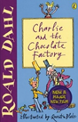  Charlie and the Chocolate Factory  Roald Dahl  Finished: ___ / ___ / ___ | 2  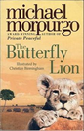  The Butterfly Lion  Michael Morpurgo  Finished: ___ / ___ / ___ | 3  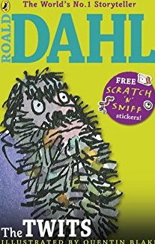  The Twits  Roald Dahl  Finished: ___ / ___ / ___ | 4  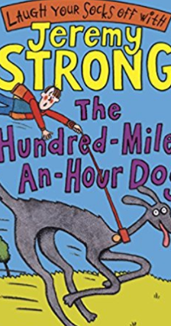  The Hundred mile and hour Dog  Jeremy strong  Finished: ___ / ___ / ___
5  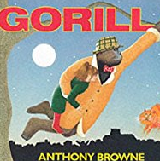  Gorilla  Anthony Browne  Finished: ___ / ___ / ___ | 6  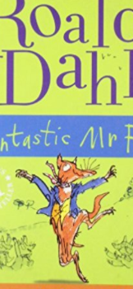  Fantastic Mr Fox  Roald Dahl  Finished: ___ / ___ / ___ | 7  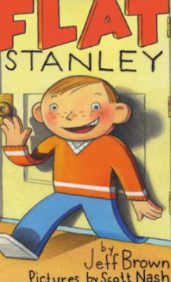  Flat Stanley  Jeff Brown  Finished: ___ / ___ / ___ | 8  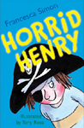  Horrid Henry  Francesca Simon  Finished: ___ / ___ / ___
9  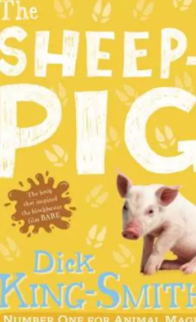  The Sheep pig  Dick King Smith  Finished: ___ / ___ / ___ | 10  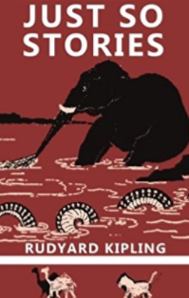  Just so stories  Rudyard kipling  Finished: ___ / ___ / ___ | 11  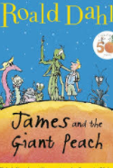  James and the Giant Peach  Roald Dahl  Finished: ___ / ___ / ___ | 12  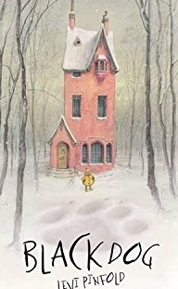  Blackdog  Levi Pinfold  Finished: ___ / ___ / ___
13  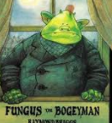  Fungus The Bogeyman  Raymond Briggs  Finished: ___ / ___ / ___ | 14  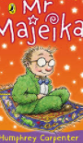  Mr Majeka  Humphrey Carpenter  Finished: ___ / ___ / ___ | 15  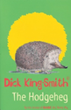  The Hodgeheg  Dick King-Smith  Finished: ___ / ___ / ___ | 16  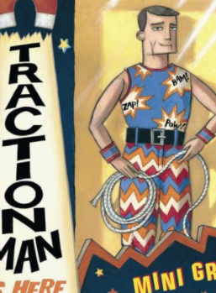  Traction Man is Here  Finished: ___ / ___ / ___
17  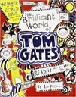  The Brilliant World of Tom Gates  Liz Pichon  Finished: ___ / ___ / ___ | 18  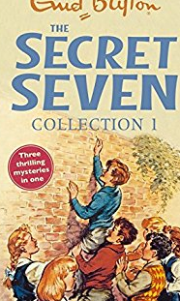  Secret seven  Enid Blyton  Finished: ___ / ___ / ___ | 19  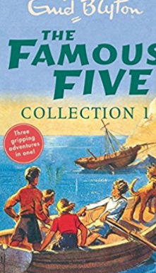  Famous Five  Enid Blyton  Finished: ___ / ___ / ___ | 20  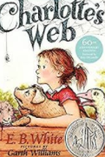  Charlotte’s Webb  E.B White  Finished: ___ / ___ / ___
21  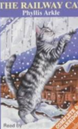  Railway Cat  Phylis Arkle  Finished: ___ / ___ / ___ | 22  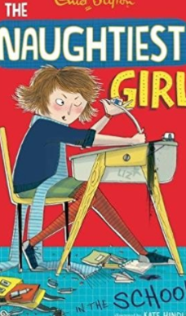  The Naughtiest girl in the School  Enid Blyton  Finished: ___ / ___ / ___ | 23  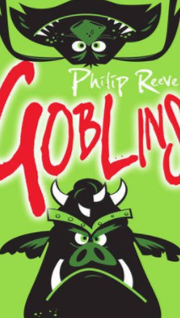  Goblins  Philip Reeve  Finished: ___ / ___ / ___ | 24  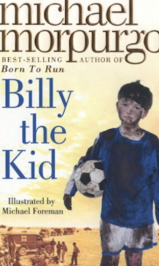  Billy the Kid  Michael Morpurgo  Finished: ___ / ___ / ___
25  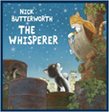  The Whisperer  Nick Butterworth  Finished: ___ / ___ / ___ | 26  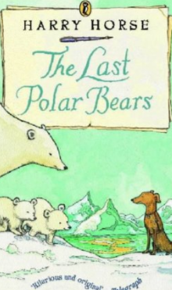  The last polar Bears  Harry horse  Finished: ___ / ___ / ___ | 27  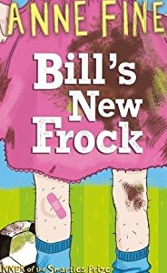  Bill’s New Frock  Anne Fine  Finished: ___ / ___ / ___ | 28  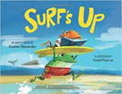  Surf’s Up  Kwame Alexander  Finished: ___ / ___ / ___
29  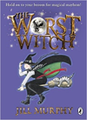  The Worst Witch  Jill Murphy  Finished: ___ / ___ / ___ | 30  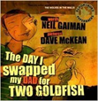  The Day I Swapped my Dad for a Goldfish  Neil Gaiman  Finished: ___ / ___ / ___ | 31  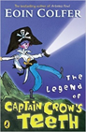  The Legend of Captain Crow’s Teeth  Eoin Colfer  Finished: ___ / ___ / ___ | 32  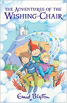  The Adventures of the Wishing Chair  Enid Blyton  Finished: ___ / ___ / ___
33  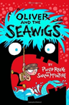  Oliver and the Seawigs  Philip Reeve  Finished: ___ / ___ / ___ | 34  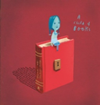  A Child of Books  Oliver Jeffers  Finished: ___ / ___ / ___ | 35  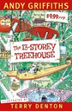  The 13-Storey Treehouse  Andy Griffiths  Finished: ___ / ___ / ___ | 36  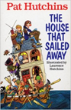  The House that Sailed Away  Pat Hutchins  Finished: ___ / ___ / ___
37  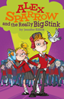  Alex Sparrow and the Really Big Stink  Jennifer Killick  Finished: ___ / ___ / ___ | 38  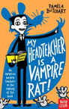  My Headteacher is a Vampire  Pamela Butchart  Finished: ___ / ___ / ___ | 39  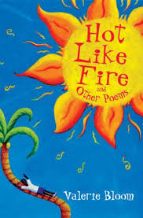  Hot Like Fire  Valerie Bloom  Finished: ___ / ___ / ___ | 40  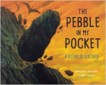  The Pebble in my Pocket  Meredith Hooper  Finished: ___ / ___ / ___
41  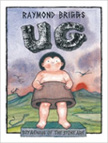  Ug: Boy Genius of the Stone Age  Raymond Briggs  Finished: ___ / ___ / ___ | 42  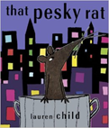  That Pesky Rat  Lauren Child  Finished: ___ / ___ / ___ | 43  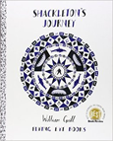  Shackleton’s Journey  William Grill  Finished: ___ / ___ / ___ | 44  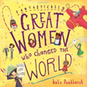  Fantastically Great Women Who changed the world  Kate Pankhurst  Finished: ___ / ___ / ___
45  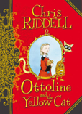  Ottoline and the Yellow Cat  Chris Riddell  Finished: ___ / ___ / ___ | 46  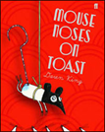  Mouse Noses on Toast  Darren Fletcher  Finished: ___ / ___ / ___ | 47  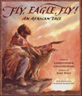  Fly, Eagle, Fly!  Christopher Gregorowski  Finished: ___ / ___ / ___ | 48  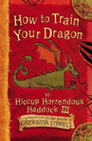  How to Train Your Dragon  Cressida Cowell  Finished: ___ / ___ / ___
49  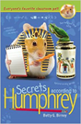  Secrets according to Humphrey  Betty G. Birney  Finished: ___ / ___ / ___ | 50  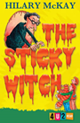  The Sticky Witch  Hilary McKay  Finished: ___ / ___ / ___ | 51  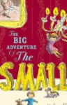  The Big Adventure of the Smalls  Helen Stephens  Finished: ___ / ___ / ___ | 52  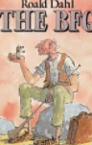  BFG  Roald Dahl  Finished: ___ / ___ / ___
53  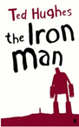  The Iron Man  Ted Hughes  Finished: ___ / ___ / ___ | 54  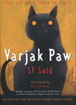  Varjak Paw  S F Said  Finished: ___ / ___ / ___ | 55  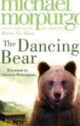  The Dancing Bear  Michael Morpurgo  Finished: ___ / ___ / ___ | 56  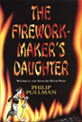  The Firework-Maker’s Daughter  Philip Pullman  Finished: ___ / ___ / ___
57  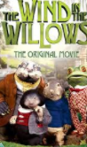  Wind in the Willows  Kenneth Grahame  Finished: ___ / ___ / ___ | 58  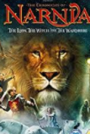  The Lion the Witch and the Wardrobe  Finished: ___ / ___ / ___ | 59  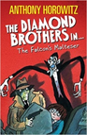  The Falcon’s Malteser  Anthony Horowitz  Finished: ___ / ___ / ___ | 60  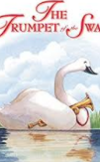  Trumpet of the Swan  E.B. White  Finished: ___ / ___ / ___
61  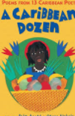  A Caribbean dozen  Finished: ___ / ___ / ___ | 62  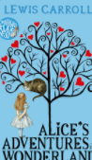  Alice’s Adventures in Wonderland  C.S.Lewis  Finished: ___ / ___ / ___ | 63  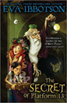  The Secret of Platform 13  Eva Ibbotson  Finished: ___ / ___ / ___ | 64  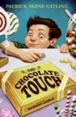  The Chocolate Touch  Patrick Skene Catling  Finished: ___ / ___ / ___
65  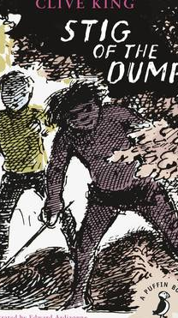  Stig of the dump  Clive King  Finished: ___ / ___ / ___ | 66  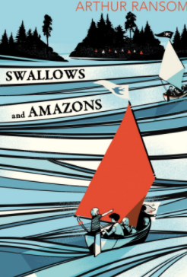  Swallows and Amazons  Arthur Ransome  Finished: ___ / ___ / ___ | 67  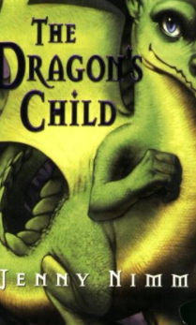  The Dragon’s child  Jenny Nimm  Finished: ___ / ___ / ___ | 68  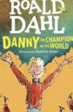  Danny the Champion of the World  Roald Dahl  Finished: ___ / ___ / ___
69  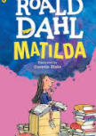  Matilda  Roald Dahl  Finished: ___ / ___ / ___ | 70  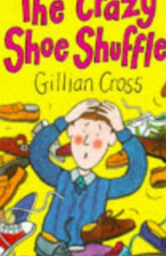  The Crazy Shoe Shuffle  Gillian Cross  Finished: ___ / ___ / ___ | 71  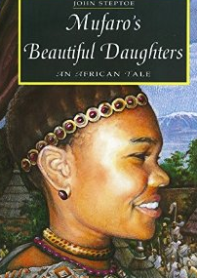  Mufano’s Beautiful Daughters  John Steptoe  Finished: ___ / ___ / ___ | 72  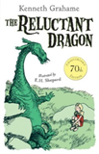  The Reluctant Dragon  Kenneth Grahame  Finished: ___ / ___ / ___
73  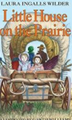  Little House on the Prairie  Laura Ingalls Wilder  Finished: ___ / ___ / ___ | 74  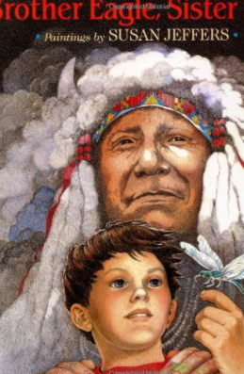  Brother Eagle, Sister Sky  Susan Jeffers  Finished: ___ / ___ / ___ | 75  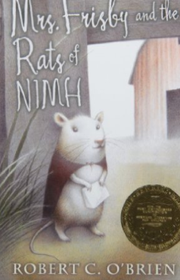  Mrs Frisby and the Rats of NIMH  Robert C O’Brian  Finished: ___ / ___ / __  _ | 76  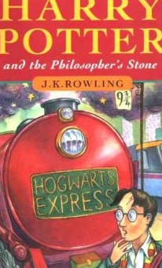  Harry potter and the Philosopher’s Stone  J.K.Rowling  Finished: ___ / ___ / ___
77  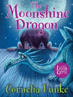  The Moonshine Dragon  Cornelia Funke  Finished: ___ / ___ / ___ | 78  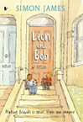  Leon and Bob  Simon James  Finished: ___ / ___ / ___ | 79  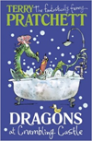  Dragons at Crumbling Castle  Terry Pratchett  Finished: ___ / ___ / ___ | 80  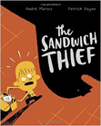  The Sandwich Thief  Andre Marois  Finished: ___ / ___ / ___
81  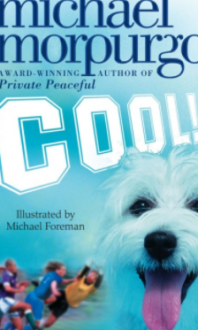  Cool  Michael Morpurgo  Finished: ___ / ___ / ___ | 82  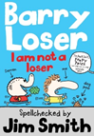  I am not a Loser  Jim Smith  Finished: ___ / ___ / ___ | 83  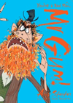  You’re a bad man Mr Gum  Andy Stanton  Finished: ___ / ___ / ___ | 84  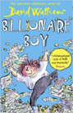  Billionaire Boy  David Walliams  Finished: ___ / ___ / ___
85  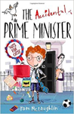  The Accidental Prime Minister  Tom McLaughlin  Finished: ___ / ___ / ___ | 86  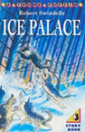  Ice Palace  Robert Swindells  Finished: ___ / ___ / ___ | 87  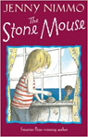  The Stone Mouse  Jenny Nimmo  Finished: ___ / ___ / ___ | 88  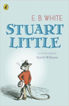  Stuart Little  E.B White  Finished: ___ / ___ / ___
89  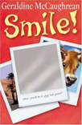  Smile  Geraldine McCaughrean  Finished: ___ / ___ / ___ | 90  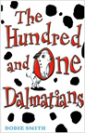  The Hundred and One Dalmations  Dodie Smith  Finished: ___ / ___ / ___ | 91  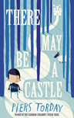  There May Be A Castle  Piers Torday  Finished: ___ / ___ / ___ | 92  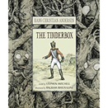  The Tinderbox  Hans Christian Anderson  Finished: ___ / ___ / ___
93  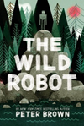  The Wild Robot  Peter Brown  Finished: ___ / ___ / ___ | 94  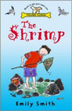  The Shrimp  Emily Smith  Finished: ___ / ___ / ___ | 95  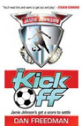  The Kick Off  Dan Freedman  Finished: ___ / ___ / ___ | 96  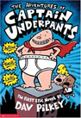  The Adventures of Captain Underpants  Dav Pilkey  Finished: ___ / ___ / ___
97  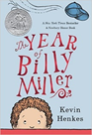  The Year of Billy Miller  Kevin Henkes  Finished: ___ / ___ / ___ | 98  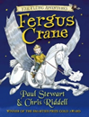  Fergus Crane  Paul Stewart and Chris Riddell  Finished: ___ / ___ / ___ | 99  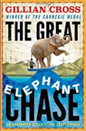  The Great Elephant Chase  Gillian Cross  Finished: ___ / ___ / ___ | 100  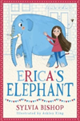  Erica’s Elephant  Sylvia Bishop  Finished: ___ / ___ / ___

